**FUNCTIONAL AND TECHNICAL COMBINED DOCUMENTATION**

**Page (37): Login (Front End Url:** http://localhost:8100/page37/page37)

**Functional Picture:**

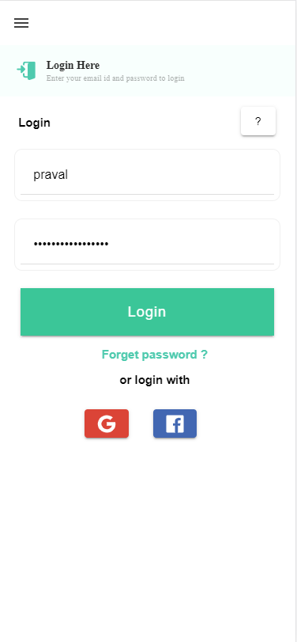

**Technical Explanation (Front End and Back End):**

**In Page37.tsx, we are calling following one method based API:**

1. login: see view.py python file from BackEnd

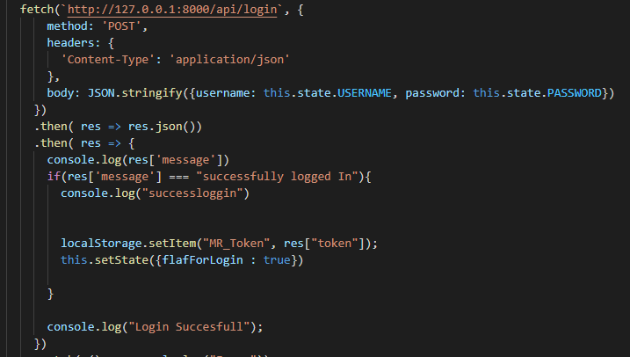

**As you can see above, there is one url:**

* [**http://127.0.0.1:8000/api/**](http://127.0.0.1:8000/api/)**login --🡪** login

**Now we write login function which returns the token associated with the user and make api route for the same.**

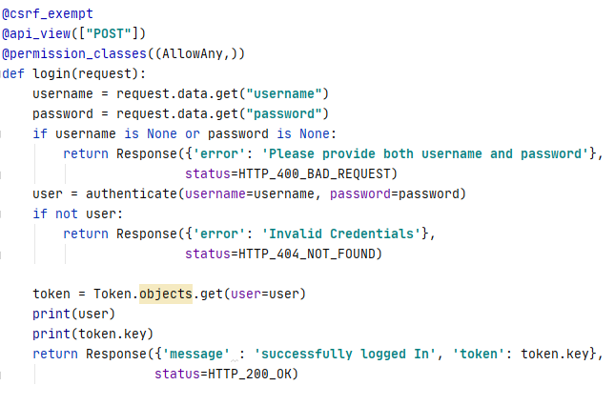

Here we have created a login function which handled the POST request and get username and password as params and then authenticate them if they are correct then return the token if that was created during “SignUp” if they are correct else return the not found response.

We have made the api route for the same in the urls.py



DONE!!